Practical Exam   
Subject: WED201c  
Duration: 120 minutes

**Objectives:**

1. Create a Cascading Style Sheet (CSS) and link it to the HTML files. **(Without changing the html)**

2. Create a javascript file (js) and link it to the HTML files. **(Without changing the html)**

**Background:**

In this practical exam, you are going to use some files in the **Resource folder** to finish the exam.

**Before styling portfolio.html page**

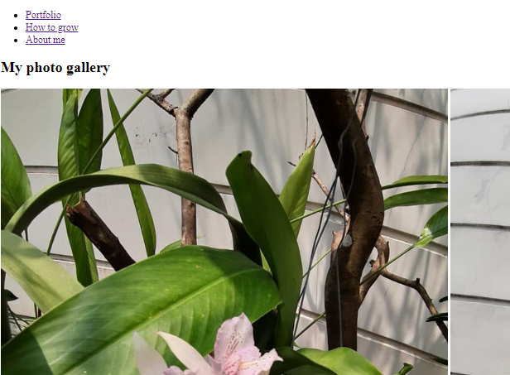

**After styling portfolio.html page  
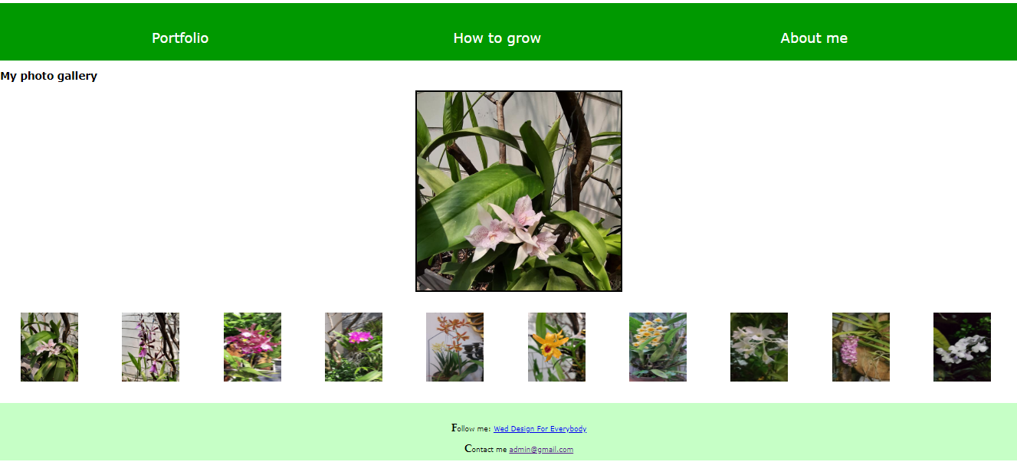**

**After styling howtogrow.html page**

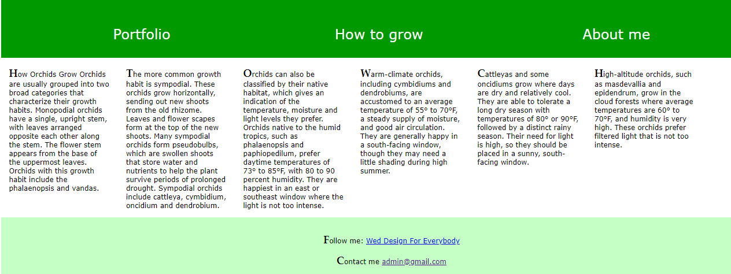

**After styling aboutme.html page**



**Requirements:**

1. Create a file called **orchidBlog.css** and save it in a given **Resource/css folder.** In this file you can use any css properties to style some html pages. You can view the styled pages in folder “**Template**”
2. Create a file called **orchidBlog.js** and save it in a given **Resource/js folder.** In file **orchidBlog.js,** using javascript to create a kind of photo gallery and validate a form.
   1. Write a function **zoomout()** to change the background image of tag div(file portfolio.html) when you click your mouse on the small image; This function has one input parameter (input parameter is the clicked small image ). This function changes the background image of the div(id="frame"). So you're creating a kind of photo gallery here.
   2. Write a function **warning()** to validate the form (file aboutme.html) when a user clicks the button “send”.

* If any form fields are empty, the message will be displayed “Please fill out all fields”
* If all fields are not empty then a confirm message “Are you sure about your information?” will be displayed

+ If the user clicks “OK” the web page display a message “Message sent”

+ If the user clicks “Cancel”, the web page does nothing

1. When submitting your result, please submit the **whole folder** includes **all your files and sub-folders but not just only CSS file and js file**.

**Evaluation:**

**CSS: 5 points**

1. Header, section, and footer tags do not overlap? **[0.5 point]**
2. Links in header tag are aligned with good look and decorated with any color and none underline?   
    **[0.5 point]**
3. The large image in the div tag is aligned to the center of its container? **[0.5 point]**
4. All small images are not overlapped and you should keep spacing around them **[1 point]**
5. All texts in the footer tag should are styled to look like the sample **[0.5 point]**
6. All paragraphs in section tag in “howtogrow.html” page should be divided into 6 columns **[1 point]**
7. The first letter of p tags should be styled with font size and font face properties **[0.5 point]**
8. The form of the aboutme.html page is aligned to the center of its container? **[0.5 point]**

**Java script: 5 points**

1. When you click your mouse on the small image, the background image in the div tag(id=” frame”) should be changed to look like clicked image **[2 points]**
2. If any form fields are empty then a message “please fill out all fields” will be displayed. **[1 point]**
3. If all form fields are not empty then a confirm message “Are you sure your information?” will be displayed **[1point]**

+ If the user clicks “OK” the web page display a message “Message sent**” [0.5 point]** and clicks “Cancel” the web page does nothing **[0.5 point]**

**Total: 10 points**

**(Students do not change the path of all files in Resource folder)**

The End